Step 0 Intake + Interview Filing Status, Dependency
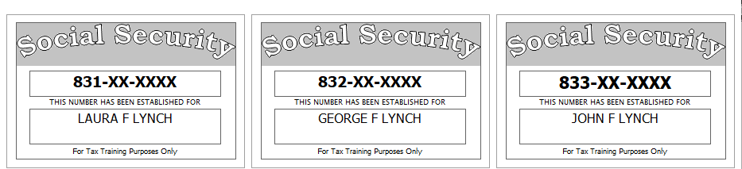

Laura had a serious accident in June, 2018, and stopped working. Laura is now totally and permanently disabled (per SSA Guidelines).
Laura’s divorce decree states that her ex-husband is to claim their son, John, as a dependent on his return even though Laura provides all the support for both their children. Laura has provided her ex a signed form 8332 to facilitate this.
Reference: 4012 Tab A, B, C
Tool: IRS Interactive Tax Assistant (link on Preparer page)
Tool: AARP Resource Tool for Counselors (Laminated Flow Chart)
Tool: TP4F Qualifying Child/Qualifying Relative Flowchart Tool (link on Preparer page)
Tool: Dependent Calculator (link on Preparer page)

Step 1 Basic Information
Use the Filing Status from Step 0
Use Intake Sheet and Social Security cards
Extra Interview information for New Jersey:
- All dependents have health insurance (as of the time the return is filed)
- Laura wants her contribution to the Gubernatorial Election Campaign Fund to be handled the same as her contribution to the Presidential Election Campaign Fund.
Reference: 4012 Tab B
Tool: NJ Municipality Code Lookup Tool (link on Preparer page)
Tool: NJ 1040 Instructions – Municipality Code Table
Hint: For Profile, use Basic (No Profile)
Hint: Use names from SS Cards (NOT Intake Sheet)
Hint: A simple NJ return will be added after filling in the Federal Personal Information screen. Answer only the subset of the NJ Basic questions asked
Hint: Do not go to the State Section and do anything until you are done with the Federal Section and Health Insurance sections. Use the NJ Checklist to record things you will need to remember when doing the State Section later.
Hint: You do not need to remember or record the NJ PIN
NJ: Fill in Basic Information section of NJ Checklist and the Disability status line in the Subtractions from Income section now
Federal AGI: 0 Federal Refund: 0 NJ Refund: 0
Step 2 Prior Year Return – State Income Tax Refund
Laura had a NJ income tax refund of $502.
She did not itemize last year.
Federal AGI: 0 Federal Refund: 0 NJ Refund: 0
Step 3 W-2
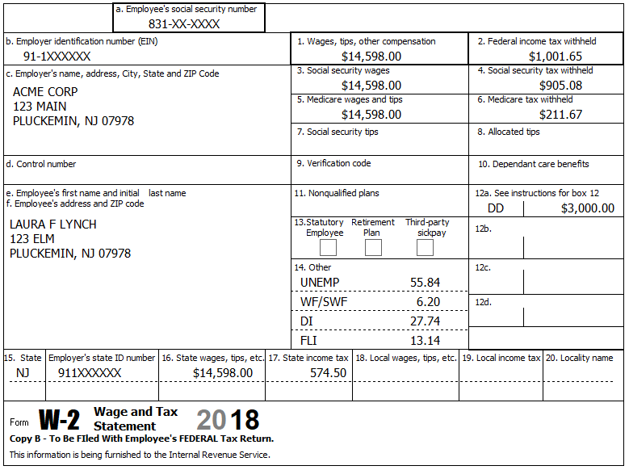
Reference: 4012 D-4 to D-6
Federal AGI: 14,598 Federal Refund: 8,118 NJ Refund: 2,690
Step 4 W-2
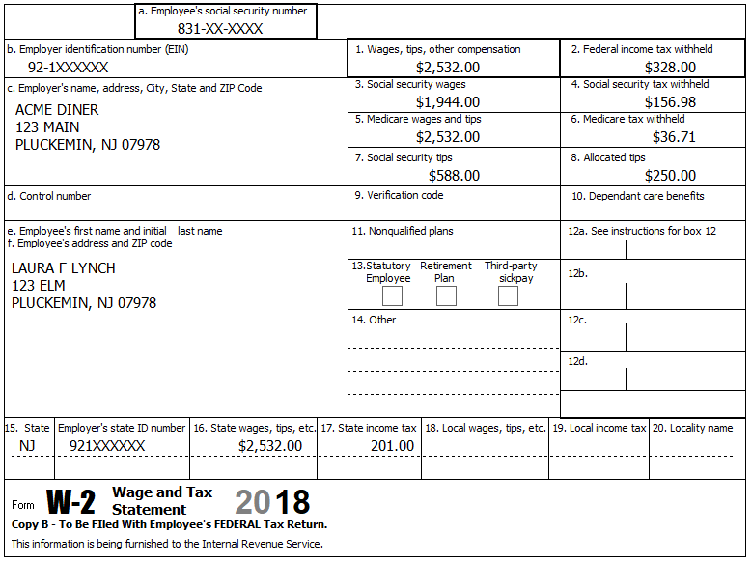
10.76 UI/WF/SWF
4.81 DI
2.28 FLI
Reference: 4012 D-4 to D-6
Hint: TSO may complain about the Social security tax in box 4 – Verify that your numbers match the form – if so, you can ignore this annoying complaint.
Federal AGI: 17,380 Federal Refund: 8,426 NJ Refund: 2,891
Step 5 1099-R
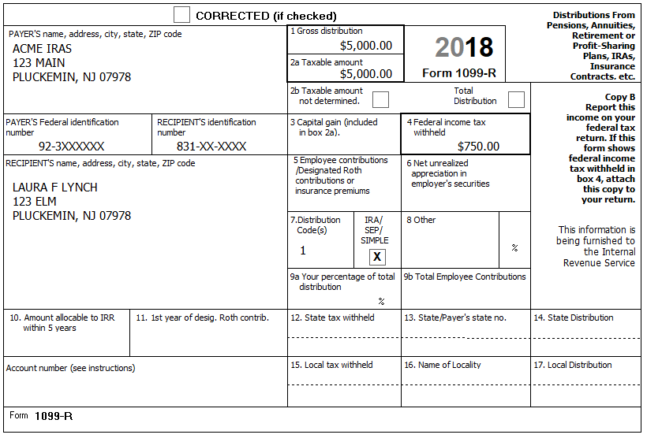
In September, Laura took an IRA distribution of $5,000 to pay off credit card debt.
Reference: 4012 D-37 to D-39
Step 5a 1099-R
Hint: Remember, Laura is permanently and totally disabled.
Federal AGI: 22,380 Federal Refund: 7,894 NJ Refund: 2,324
Step 5b 5329
Reference: 4012 H-2 to H-3
BP: Enter 5329 info now so we don’t forget.
Federal AGI: 22,380 Federal Refund: 8,394 NJ Refund: 2,324
Step 6 1099-R
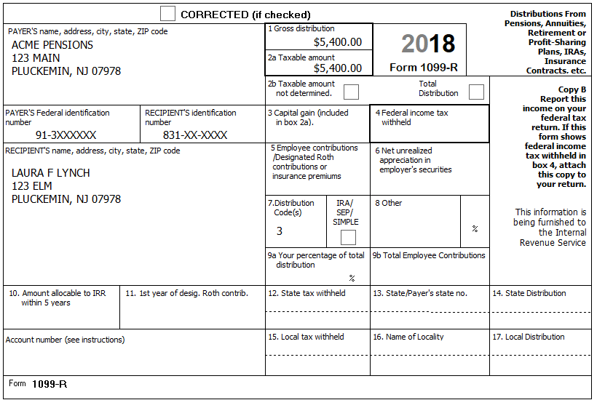
Reference: 4012 D-37 to D-39
The minimum retirement age for Laura’s job was 59.
NJ: Record disability amount on NJ Checklist (Adjustments to Line 20a)
Federal AGI: 27,780 Federal Refund: 6,878 NJ Refund: 2,181

Step 7 Self Employment
Starting on July 1, 2012, Laura started providing freelance editing services from her home.
She met all scope requirements (see Pub 4012 D-16).
Reference: 4012 D-13 to D-19
Hint: We can start by either creating the Sch C or by entering the 1099-MISC directly. We’re going to start by entering the first 1099-MISC directly
Step 7a 1099-MISC
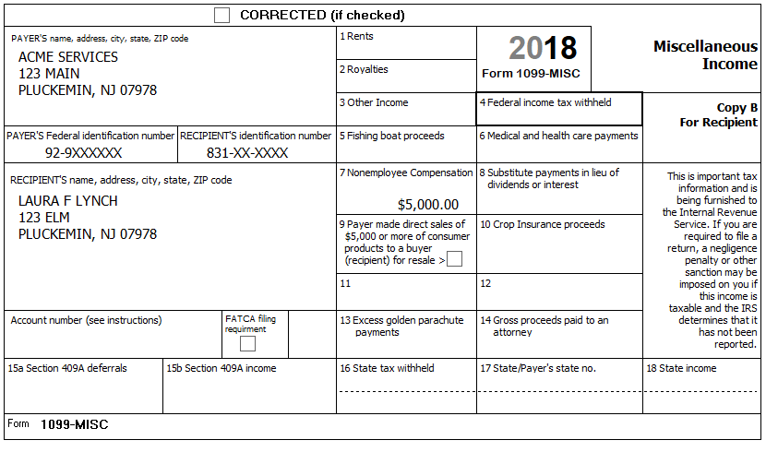
Hint: This is our first 1099-MISC, so after clicking Continue, then click the first “Create a New Schedule C Income from Business” on the “Where would you like to add the income?” screen. See next sub-step for help filling in the Basic Information for the Sch C
Federal AGI: 32,426 Federal Refund: 4,711 NJ Refund: 1,540

Step 7b Sch C – Basic Information
She had no separate business name, no EIN, and no business address (other than her home).
Note: As of 12-19-2018, TSO will only calculate the Qualified Business Income Deduction (QBID) if the Business Name field on the Sch C “Basic Information About Your Business” screen is filled in – use “LAURA LYNCH”
Tool: NAICS Search Tool (link on Preparer page)
Tool: 1040 Instructions, Sch C Business Codes table
Hint: If you can’t find an obvious match in TSO’s built-in Business Code lookup list, then an alternative is to use the online NAICS Search Tool to search for the Business Code (enter keyword “editing” in this case)
Hint: After clicking Continue, you will see the Schedule C menu – Do NOT click on any of these options now – We will come back to these later.
Federal AGI: 32,426 Federal Refund: 4,827 NJ Refund: 1,540
Step 7c 1099-MISC
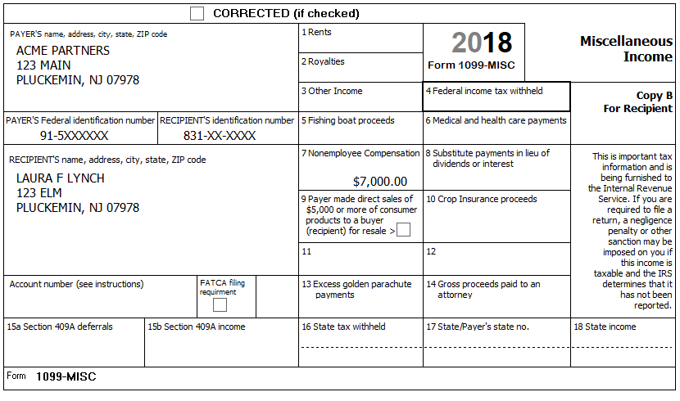
Hint: This is our second 1099-MISC for the same business, so after clicking Continue, just click the pencil button for the Document preparation Sch C on the “Where would you like to add the income?” screen. This should bring you back to the Schedule C menu.
Federal AGI: 38,932 Federal Refund: 1,862 NJ Refund: 912
Step 7d Sch C – Questions About the Operation of Your Business
Click on “Questions About the Operation of Your Business” on the Schedule C menu.
She uses the Cash Accounting Method. She has no inventory. This is not her first Sch. C. She does all the work for the business herself. There is no Prior year unallowed loss. She made no payments that would require her to file Form(s) 1099. This is not a Qualified Joint Venture
Federal AGI: 38,932 Federal Refund: 1,862 NJ Refund: 912
Step 7e Sch C – Income
Click on “Income” on the Schedule C menu.
In addition to the 1099-MISC income, she had $176 in cash income.
Federal AGI: 39,096 Federal Refund: 1,788 NJ Refund: 896
Step 7f Sch C – Car And Truck Expenses
Click on “Car And Truck Expenses” on the Schedule C menu.
Laura drove 366 total miles making deliveries for her business. She had 10,000 other miles on her car. Laura has one car (a 1969 Chevy Impala) which she bought in 2011 and began using for her work when she started working at home (08-01-2017). She does not have another vehicle available for personal use. She has a written record of her business mileage.
Hint: See 4012 D19 for suggestion of what to use for “Description of Vehicle”
Federal AGI: 38,910 Federal Refund: 1.864 NJ Refund: 912
Step 7g Sch C – Other Expenses
Click on “Other Expenses” on the Schedule C menu.
She kept a record of her expenses: $2,025 for paper, $1,048 for printer cartridges, and $8,850 for making copies.
Federal AGI: 27,834 Federal Refund: 6,863 NJ Refund: 2,177
Check: Federal 1040, Line 10 should be 9,823
Step 8 Alimony Received
Laura’s divorce decree states that her ex-husband is to pay her $300 per month alimony. Due to the loss of his job during the year, he only paid for 3 months.
Federal AGI: 28,734 Federal Refund: 6,583 NJ Refund: 2,107
Step 9 Sch A Deductions
Laura paid $1,000 for supplemental insurance and $200 to doctors/dentists for co-pays and deductibles. She also had a $60 of charitable donations (with cancelled checks).
Federal AGI: 28,734 Federal Refund: 6,583 NJ Refund: 2,107
Step 10 Child Care Credit
Laura paid Acme Day Care (EIN 93-9XXXXXX), located at 123 Main, Pluckemin, NJ 07978, for George’s and John’s care while she was at work. She paid the day-care center $1,793 ($890 for George + $903 for John). This organization is a for-profit company.
While looking for work, Laura paid her sister, Edna Loy (SSN 839-XX-XXXX), $400 to take care of John & George ($200 each). Edna lives next door at 121 Elm. Edna is self-supporting.
Reference: 4012 G-5 to G-8
Hint: Because Laura has earned income, you do not need to fill in anything on “F2441 – Child Care Credit – Page 2”.
Federal AGI: 28,734 Federal Refund: 7,056 NJ Refund: 2,107
Step 11 Credit for the Elderly or the Disabled
TaxSlayer does not automatically check eligibility for the Credit for the Elderly or the Disabled; the preparer must use the chart on page G-14 of Pub. 4012 to manually determine potential eligibility. If potentially eligible, then the preparer must provide the information necessary to calculate official eligibility and the amount of the credit, if any.
Reference: 4012 G-17
Federal AGI: 28,734 Federal Refund: 7,056 NJ Refund: 2,107
Q: Is TP eligible for this Credit? If not, why not?
Step 12 Health Insurance
The entire household had (non-Marketplace) MEC the whole year.
Federal AGI: 28,734 Federal Refund: 7,056 NJ Refund: 2,107

State Section (New Jersey)
You have collected information during several Federal Steps on your NJ Checklist – It is now time to enter that information into TSO
Step 13a NJ Checklist – Basic Information
Enter New Jersey State Return – Basic Information
Federal AGI: 28,734 Federal Refund: 7,056 NJ Refund: 2,107
Step 13b NJ Checklist – Income Subject to Tax
Enter New Jersey State Return – Income Subject to Tax
Federal AGI: 28,734 Federal Refund: 7,056 NJ Refund: 2,107
Step 13c NJ Checklist – Subtractions from Income
Enter New Jersey State Return – Subtractions from Income
Hint: Nothing new to do here (b/c TSO has removed the Disability question in this section).
Federal AGI: 28,734 Federal Refund: 7,056 NJ Refund: 2,107
Step 13d NJ Checklist – Credits
Enter New Jersey State Return – Credits
Laura paid $755 per month rent for Jan-Jun and $798 per month for Jul-Dec
Federal AGI: 28,734 Federal Refund: 7,056 NJ Refund: 2,157
Step 13e NJ Checklist – Tax
Enter New Jersey State Return – Tax
Laura did not make any purchases which would be subject to Use Tax.
Hint: Nothing new to do here.
Federal AGI: 28,734 Federal Refund: 7,056 NJ Refund: 2,157
Step 13f NJ Checklist – Payments
Enter New Jersey State Return – Payments
Hint: Nothing to do here.
Federal AGI: 28,734 Federal Refund: 7,056 NJ Refund: 2,157
Step 13g NJ Checklist – Miscellaneous Forms
Enter New Jersey State Return – Miscellaneous Forms
Hint: Nothing to do here.
Federal AGI: 28,734 Federal Refund: 7,056 NJ Refund: 2,157

e-File
Collect any final information necessary…
Step 14 E-File – EIC Checklist
This doesn’t seem to appear now.
Step 15a E-File – Return Type
Laura has a Federal refund – she would like a check mailed (per her Intake Sheet)
Hint: Federal Return Type = “E-file: Paper Check”
Step 15b E-File – Tax Preparation and E-File Information
Laura’s email is given on the Intake Sheet
Step 15c E-File – State Return(s)
Laura has a NJ refund – she would like a check mailed (per Interview)
Hint: NJ Return Type = “E-file: Paper Check”
Step 15d E-File – Taxpayer Bank Account Information
Does not apply to this return.
Step 15e E-File – Third Party Designee Info
Hint: Do NOT fill in anything here.
Step 15f E-File – Consent to Disclose Tax Return Information …
Laura agrees to GRANT consent. Enter any 5 digit PIN.
Step 15g E-File – Questions
“Was the taxpayer physically present during the entire return preparation and quality review process?” – answer Yes
Step 15h E-File – State ID (Optional)
Ignore this section
Hint: Click Save when done
Step 15i E-File – Submission
BP: Do NOT check “Is Complete” or any other boxes on this screen at this point

